**DIGITAL MARKETING**

**ASSIGNMENT :1**

|  |  |
| --- | --- |
| Name | CHITHRA A .J |
| Reg No | 960220106044 |
| NM ID | 4FEAE44EB4233BEA33BEA33C4808B6498B209 |
| Team ID | NM2023TMID10148 |

Create a blog or website using Blogspot and WordPress.  
Customize the theme design and post new article with 500  
words.

**Blogspot:**

[**https://mbpastries.blogspot.com/2023/08/making-baking.html**](https://mbpastries.blogspot.com/2023/08/making-baking.html)

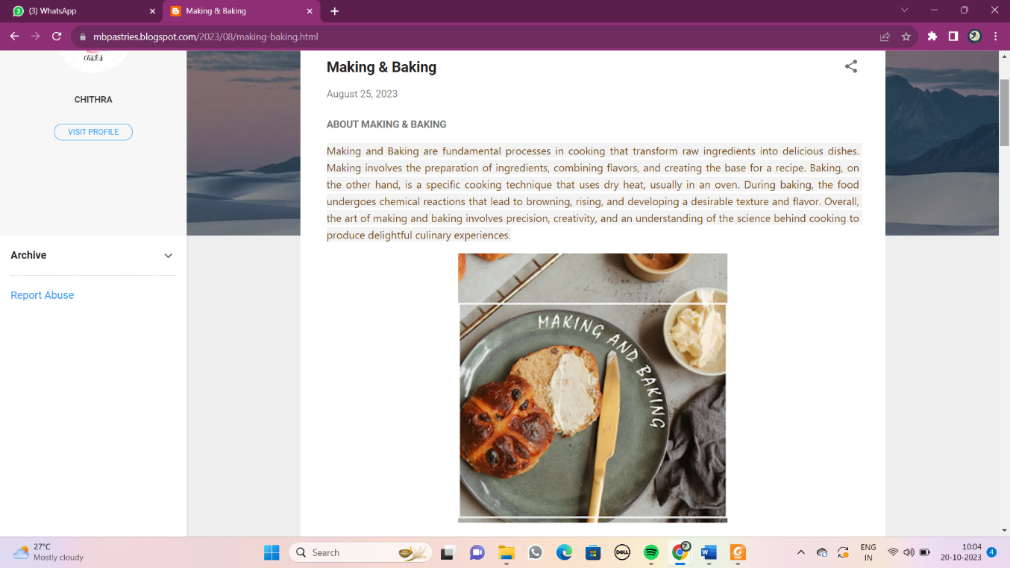

**Word press:**

[**https://mbpastry.wordpress.com/2023/10/13/making-and-baking/**](https://mbpastry.wordpress.com/2023/10/13/making-and-baking/)

